**NAME – VIKAS AHIRE**

**ROLL NO -02**

**Implementation of Steganography program in MATLAB.**

original=imread('fireelmo.jpeg');

cover=rgb2gray(original);

[row,column]=size(cover);

L=256;

stego=cover;

message=input('Enter the message to be hidden: ','s');

len=strlength(message)*8;

ascii=uint8(message);

binary_separate=dec2bin(ascii,8);

binary_all='';

for i=1:strlength(message)

binary_all=append(binary_all,binary_separate(i,:));

end

count=1;

for i=1:row

for j=1:column

if count<=len

LSB=mod(cover(i,j),2);

a=str2double(binary_all(count));

temp=double(xor(LSB,a));

stego(i,j)=cover(i,j)+temp;

count=count+1;

end

end

end

subplot(1,2,1);

imshow(cover);

title('Cover Image');

subplot(1,2,2);

imshow(stego);

title('Stego Image');

count=1;

message_in_bits='';

for i=1:row

for j=1:column

if count<=len

LSB=mod(stego(i,j),2);

message_in_bits=append(message_in_bits,num2str(LSB))

count=count+1;

end

end

end

i=1;

original_message='';

while i<=len

original_message=append(original_message,char(bin2dec(message_in_bits(1,i:i+7))));

i=i+8;

end

disp(['The original message is: ',original_message]);

**Output:**

**Enter the message to be hidden:** Remember, stay out of the fire ... super high-level tactic. Remember it, yeah?

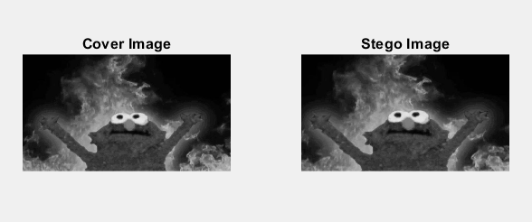

**The original message is:** Remember, stay out of the fire ... super high-level tactic. Remember it, yeah?